|  |  |  |  |
| --- | --- | --- | --- |
| Description | Current | Change | Recommended |
| AustralianSuper |  |  |  |
| Conservative Balanced | $31 | $31 | $0 |
| High Growth | $11 | $11 | $0 |
| Conservative Balanced | $8,100 | $8,100 | $0 |
| Conservative Balanced | $51 | $51 | $0 |
| AustralianSuper | $8,193 | $8,193 | $0 |
| BT Wrap Open |  |  |  |
| Investment number four | $0 | $100,000 | $100,000 |
| INVESTMENT 8 - MANAGED ACC | $0 | $67,676 | $67,676 |
| INVESTMENT 8 - MANAGED ACC | $0 | $66 | $66 |
| BT Wrap Open | $0 | $167,742 | $167,742 |
| Total | $8,193 | $175,935 | $167,742 |

|  |  |  |
| --- | --- | --- |
| Status | Current | Recommended |
| Product | AustralianSuper | BT Wrap Open |
| Balance | $8,193 | $167,742 |
| Investments | Conservative Balanced, High Growth, Conservative Balanced, Conservative Balanced | Investment number four, INVESTMENT 8 - MANAGED ACC, INVESTMENT 8 - MANAGED ACC |
| One-off Fees Subheader |  |  |
| Ongoing Fees Subheader |  |  |
| Investment Fee | $35.25 (0.43%) | $3,000.00 (1.79%) |
| Sliding Admin Fee | $0.00 (0.00%) | $251.61 (0.15%) |
| Admin Fee (Flat) | $117.00 (1.43%) | $120.22 (0.07%) |
| Expense Recovery Fee (Flat) | $0.00 | $80.00 |
| Subtotal | $152.25 | $3,451.83 |
| Total | $152.25 | $3,451.83 |
| Aggregated Total | $152.25 | $3,451.83 |
| AA Summary |  |  |

|  |  |  |
| --- | --- | --- |
| Status | Current | Recommended |
| Product | AustralianSuper | BT Wrap Open |
| Balance | $167,742 | $167,742 |
| Investments | Conservative Balanced, High Growth, Conservative Balanced, Conservative Balanced | Investment number four, INVESTMENT 8 - MANAGED ACC, INVESTMENT 8 - MANAGED ACC |
| One-off Fees Subheader |  |  |
| Ongoing Fees Subheader |  |  |
| Investment Fee | $721.74 (0.43%) | $3,000.00 (1.79%) |
| Sliding Admin Fee | $0.00 (0.00%) | $251.61 (0.15%) |
| Admin Fee (Flat) | $2,395.44 (1.43%) | $120.22 (0.07%) |
| Expense Recovery Fee (Flat) | $0.00 | $80.00 |
| Subtotal | $152.25 | $3,451.83 |
| Total | $152.25 | $3,451.83 |
| Aggregated Total | $152.25 | $3,451.83 |
| AA Summary |  |  |

|  |  |  |  |
| --- | --- | --- | --- |
| Status | Current | Risk Profile | Variance |
| Defensive Subheader |  |  |  |
| Cash | 0% | 6.00% | -6.00% |
| Australian Fixed Interest | 0% | 12.00% | -12.00% |
| International Fixed Interest | 0% | 8.00% | -8.00% |
| Defensive Subtotal | 0% | 26.00% | -26.00% |
| Growth Subheader |  |  |  |
| Australian Equities | 0% | 22.00% | -22.00% |
| International Equities | 0% | 33.00% | -33.00% |
| Property | 0% | 11.00% | -11.00% |
| Growth Subtotal | 0% | 66.00% | -66.00% |
| Alternative Subheader |  |  |  |
| Alternatives | 0% | 8.00% | -8.00% |
| Alternative Subtotal | 0% | 8.00% | -8.00% |
| Total | 100.00% | 100.00% | 100.00% |

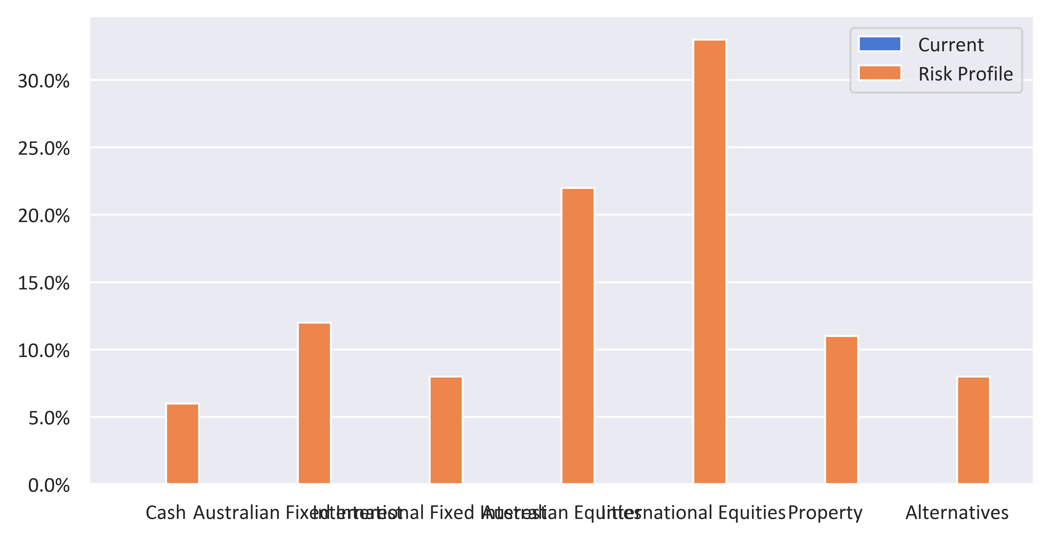

|  |  |  |  |
| --- | --- | --- | --- |
| Status | Recommended | Risk Profile | Variance |
| Defensive Subheader |  |  |  |
| Cash | 0% | 6.00% | -6.00% |
| Australian Fixed Interest | 0% | 12.00% | -12.00% |
| International Fixed Interest | 0% | 8.00% | -8.00% |
| Defensive Subtotal | 0% | 26.00% | -26.00% |
| Growth Subheader |  |  |  |
| Australian Equities | 0% | 22.00% | -22.00% |
| International Equities | 0% | 33.00% | -33.00% |
| Property | 0% | 11.00% | -11.00% |
| Growth Subtotal | 0% | 66.00% | -66.00% |
| Alternative Subheader |  |  |  |
| Alternatives | 0% | 8.00% | -8.00% |
| Alternative Subtotal | 0% | 8.00% | -8.00% |
| Total | 100.00% | 100.00% | 100.00% |

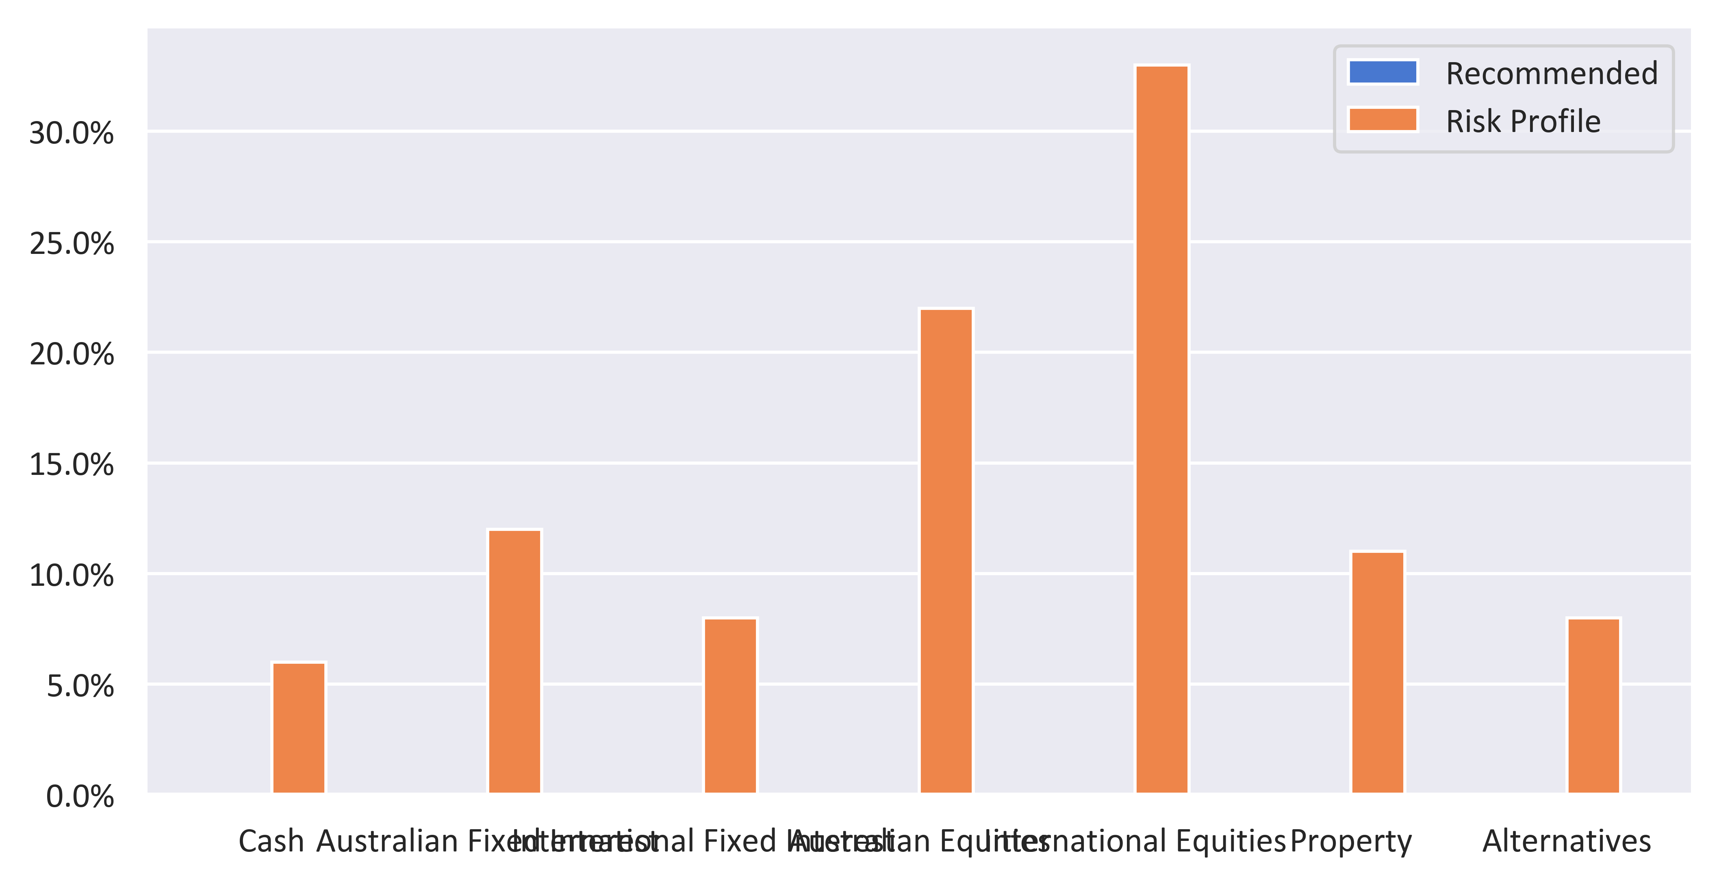

|  |  |  |  |  |
| --- | --- | --- | --- | --- |
| Status | Current | Risk Profile | Recommended | Variance |
| Defensive Subheader |  |  |  |  |
| Cash | 0% | 6.00% | 0% | -6.00% |
| Australian Fixed Interest | 0% | 12.00% | 0% | -12.00% |
| International Fixed Interest | 0% | 8.00% | 0% | -8.00% |
| Defensive Subtotal | 0% | 26.00% | 0% | -26.00% |
| Growth Subheader |  |  |  |  |
| Australian Equities | 0% | 22.00% | 0% | -22.00% |
| International Equities | 0% | 33.00% | 0% | -33.00% |
| Property | 0% | 11.00% | 0% | -11.00% |
| Growth Subtotal | 0% | 66.00% | 0% | -66.00% |
| Alternative Subheader |  |  |  |  |
| Alternatives | 0% | 8.00% | 0% | -8.00% |
| Alternative Subtotal | 0% | 8.00% | 0% | -8.00% |
| Total | 100.00% | 100.00% | 100.00% | 0.00% |

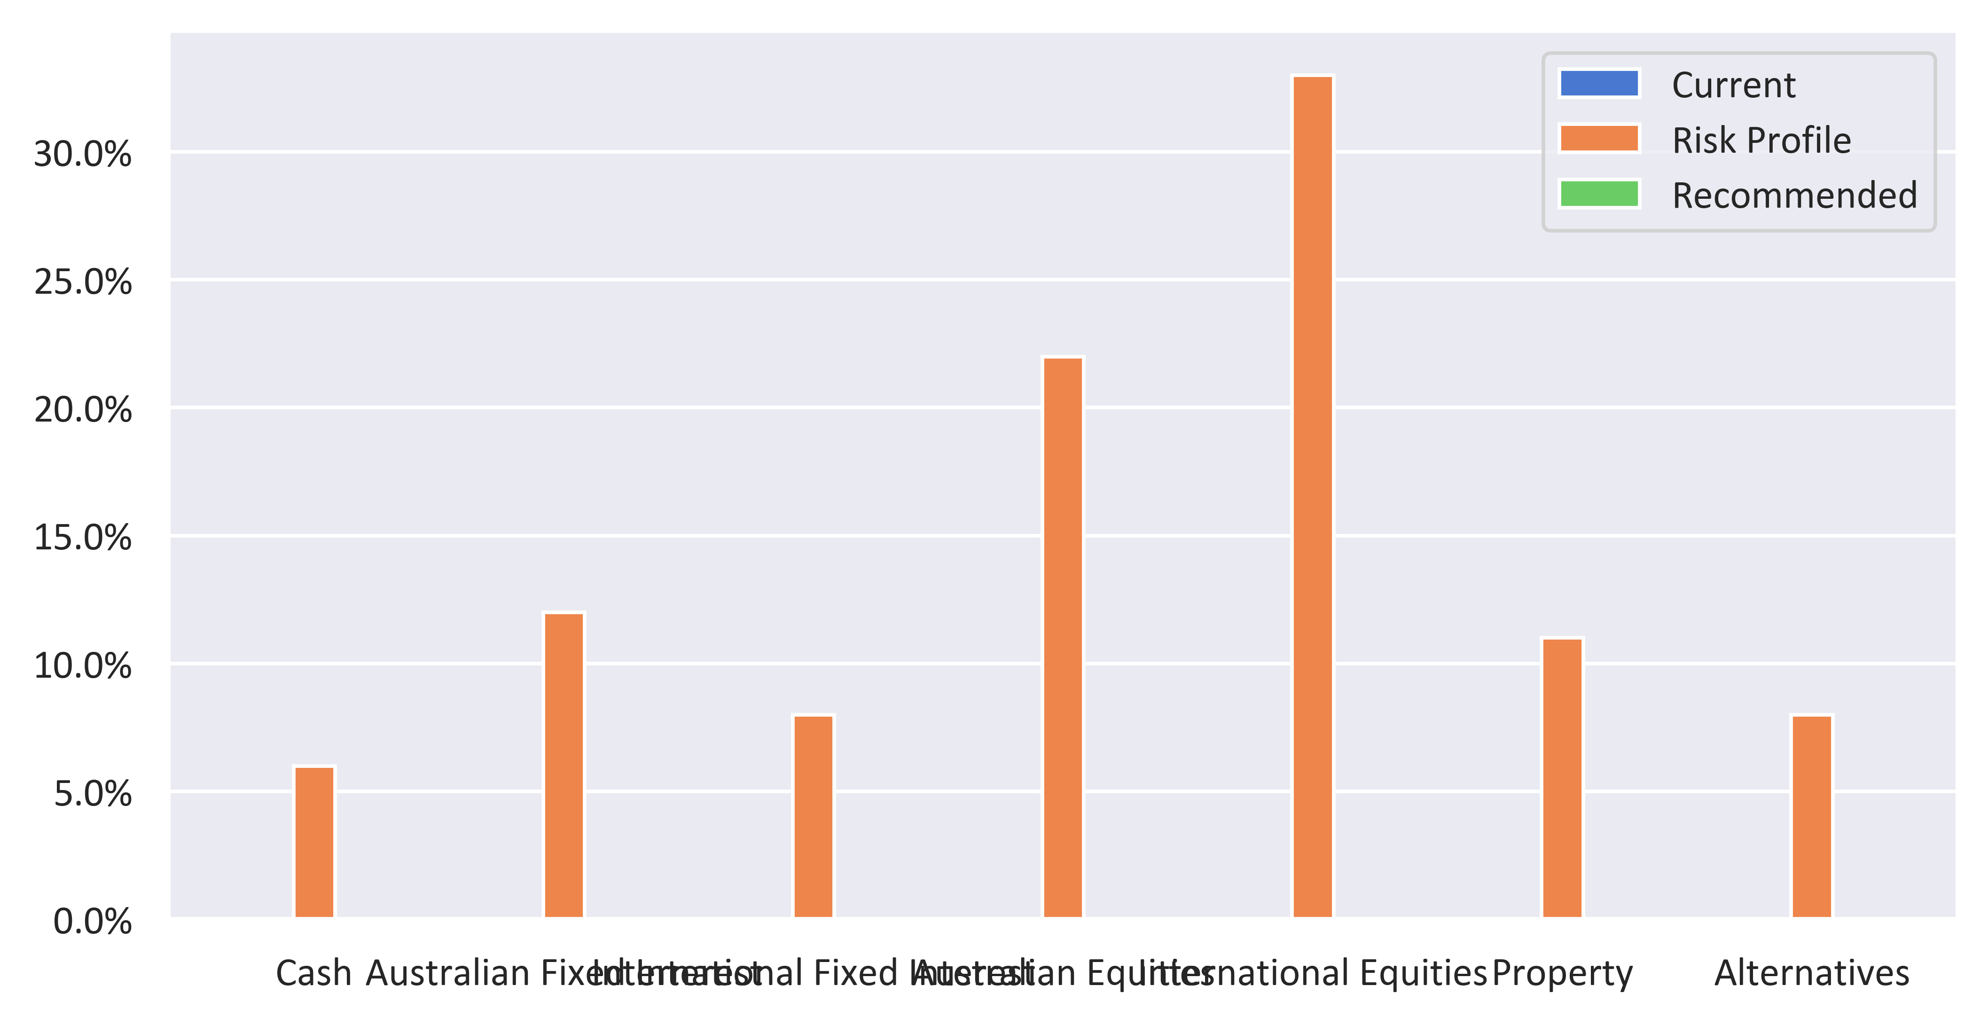

|  |  |  |  |
| --- | --- | --- | --- |
| Status | Current | Recommended | Variance |
| Defensive Subheader |  |  |  |
| Cash | 0% | 0% | 0% |
| Australian Fixed Interest | 0% | 0% | 0% |
| International Fixed Interest | 0% | 0% | 0% |
| Defensive Subtotal | 0% | 0% | 0% |
| Growth Subheader |  |  |  |
| Australian Equities | 0% | 0% | 0% |
| International Equities | 0% | 0% | 0% |
| Property | 0% | 0% | 0% |
| Growth Subtotal | 0% | 0% | 0% |
| Alternative Subheader |  |  |  |
| Alternatives | 0% | 0% | 0% |
| Alternative Subtotal | 0% | 0% | 0% |
| Total | 100.00% | 100.00% | 100.00% |

